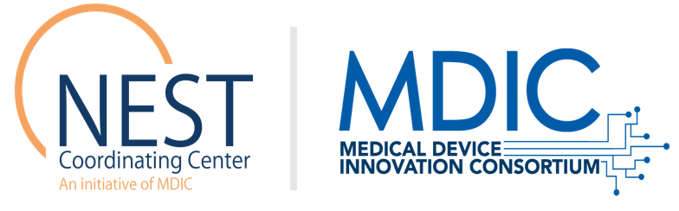
NEST Coordinating Center
www.nestcc.org

Posting Date: July 21, 2021
Due Date: August 20, 2021
Extended Due Date: September 10, 2021

National Evaluation System for health Technology Coordinating Center (NESTcc)

Call for Experts for the NESTcc Active Surveillance Data Curation Working Group
Instructions
Please provide the information requested below and send your completed form as a PDF along with any other relevant documentation to NESTcc@mdic.org by Friday, September 10, 2021 at 5:00 p.m. ET. This application may be submitted as either a self-nomination or to nominate another individual. If this application is to nominate someone other than yourself, NESTcc reserves the right to share the information in the application with the nominated individual and may reach out to the nominated individual to collect any additional information.

Nomination
Please select one of the following options:
☐ Self-nomination: I am nominating myself to serve on the Active Surveillance Data Curation Working Group.
☐ Nomination: I am nominating someone other than myself to serve on the Active Surveillance Data Curation Working Group.

Applicant Information
Include the required applicant information. Any additional information may be provided by adding additional fields to the table.

Required Field | Applicant Information
Name of Nominated Individual (First and Last)
Professional Degree(s)
Current Title
Primary Organization Affiliation
E-mail
Phone Number
Complete the additional rows below only if you are nominating someone other than yourself. The information below should be your information, while the information above should pertain to the nominated individual.

Additional Field | Nominator Information
Name of Nominator (First and Last)
Current Title
Primary Organization Affiliation
E-mail
Phone Number

The application continues on the next page.

Overview of Expertise
Your responses to sections A – C should not exceed two pages. You are not required to use the full two pages.

- Prior Experience
- Describe any relevant prior experience.
- Describe any participation in similar efforts that will help spur the development of NESTcc’s Active Surveillance Data Curation Working Group. Similar efforts include, but are not limited to, NESTcc Methods Subcommittee, the PCORI Methodology Committee, PCORnet, MDEpiNet, the Medical Device Registry Task Force, Sentinel, the International Medical Device Regulators Forum (IMDRF), the Clinical Trials Transformation Initiative (CTTI) and the Electrophysiology Predictable and Sustainable Implementation of National Registries (EP PASSION).

- Stakeholder Perspective
- Describe the primary stakeholder perspective you would represent on the Working Group.
- Describe the value of this stakeholder perspective to the success of the Working Group.

- Alignment to NESTcc Mission
- Describe your interest in working with NESTcc to achieve its mission and overall strategic and operating goals.

References
Please provide up to three references who can speak to your expertise and prior experience participating in similar initiatives.

Name | Relevant Title and Organization | E-mail | Phone Number

To learn more about NESTcc, visit our website (www.nestcc.org) or email us at NESTcc@mdic.org with any additional questions.

